EDUCATIONAL VISITS AT ROOKERY FARM

We have a mixed arable and livestock farm at Rookery Farm Pidley and would like to offer educational visits for school children. These visits are funded by Natural England and are free of charge to schools and health/educational care services.
Contact details
Clair German
Rookery farm
Fen Road
Pidley
Huntingdon
PE283DF
Tel. 07765400697
Email. clairgerman@rookerywaters.co.uk
Please contact me to arrange a preliminary visit or to discuss insurance details etc.

About our Farm
Rookery Farm is a 99 hectare (240 acre) farm near Warboys. The farm grows wheat, barley and oil seed rape. There are also grass fields and a herd of beef cattle. We have fishing lakes, woodland, ponds and conservation areas. It is very much a traditional mixed cropping and livestock farm that has modernised and diversified in a sustainable way. We are very keen to show people around and explain to them how and why things are done on a farm.

How to get here
- From Pidley village on the B1040 turn down Fen Road (no through road)
- Follow Fen Road to the very end and past the golf course (2.5 miles)
- Sat. Nav. PE28 3DF

WHAT YOU CAN SEE ON THE FARM
- A tour around the fields looking at the different crops grown and how the cropping makes up the local landscape.
- See wildlife conservation measures, funded by countryside stewardship schemes, working on the farm.
- Tractors and other farm machinery.
- Beef animals
- Fishing lakes, woodland, ponds and reed beds.
- Chickens kept for egg laying

ACTIVITIES WE CAN PROVIDE ON THE FARM
- Guided tour of farm and discussion on cropping, livestock and farm diversification.
- Chance to see farm machinery up close and possibly working and an explanation of what all the different implements are used for.
- Watch the cattle moved through the handling equipment and learn about how we look after their health and dietary requirements. Discuss their individual ear tags, passports and the whole traceability system.
- We can take you down to the fishing lakes, watch some angling and show you a net full of the different species of fish.
- Pond dipping
- Catch Gold Fish from a small pond
- Identification of different trees

AREAS AVAILABLE FOR YOUR OWN FIELDWORK
- There are many picnic areas and covered areas if the weather is wet
- Woodland and hedgerow areas for fieldwork including some laid hedgerows
- We have some extensively managed grassland which has several large ponds, a wooded area and a large bird-hide for viewing.
- At the end of the last ice age trees in our area were buried and preserved under the soil, these trees called “bog oaks” are available to see and study here.

We can provide you with identification sheets for trees, animals and details of cropping, livestock breeds or any other information that you may require
The photograph shows our chickens which provide our family with lovely eggs (real free range!)

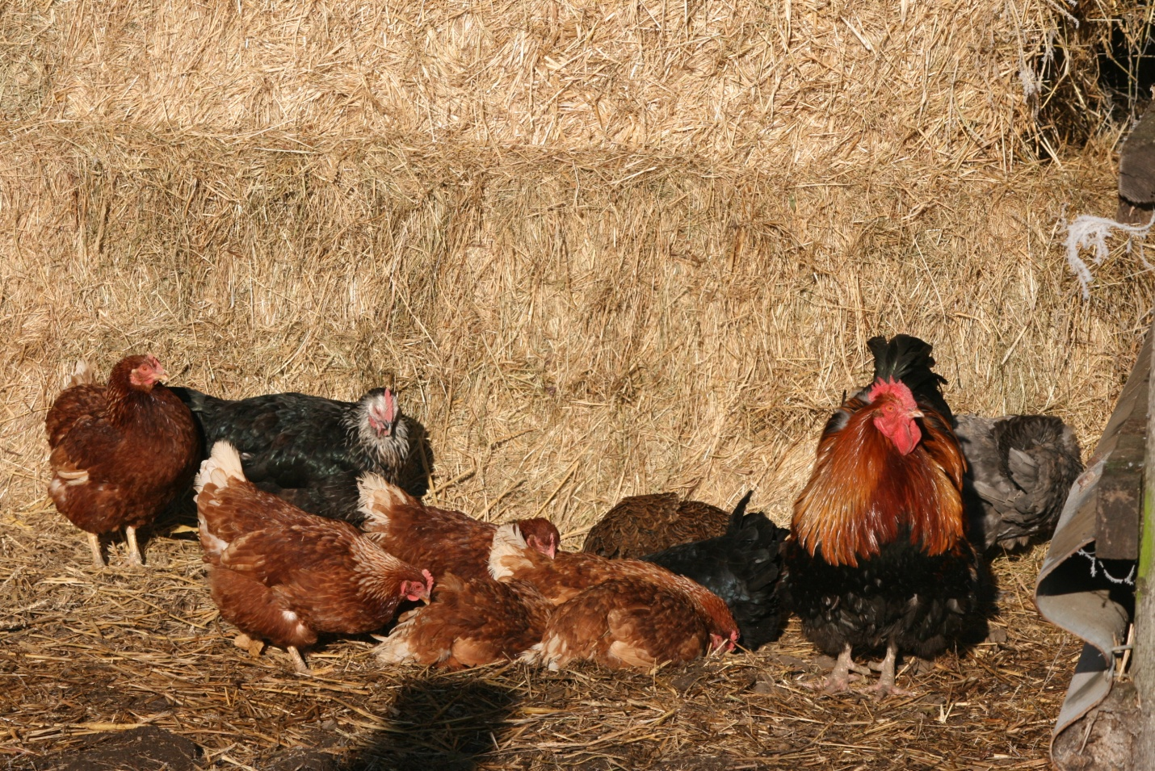

This is a picture of our combine harvester – this year will be its 29th season

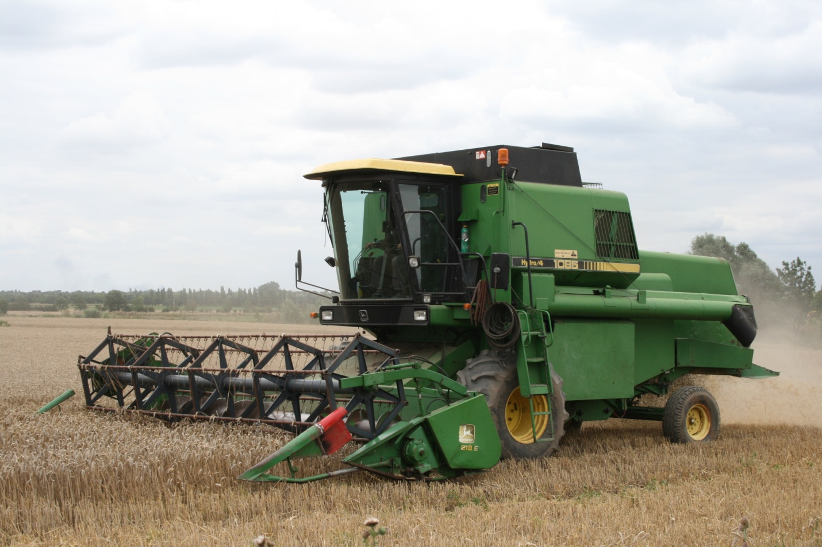

This is a picture of our British White cow with her calf

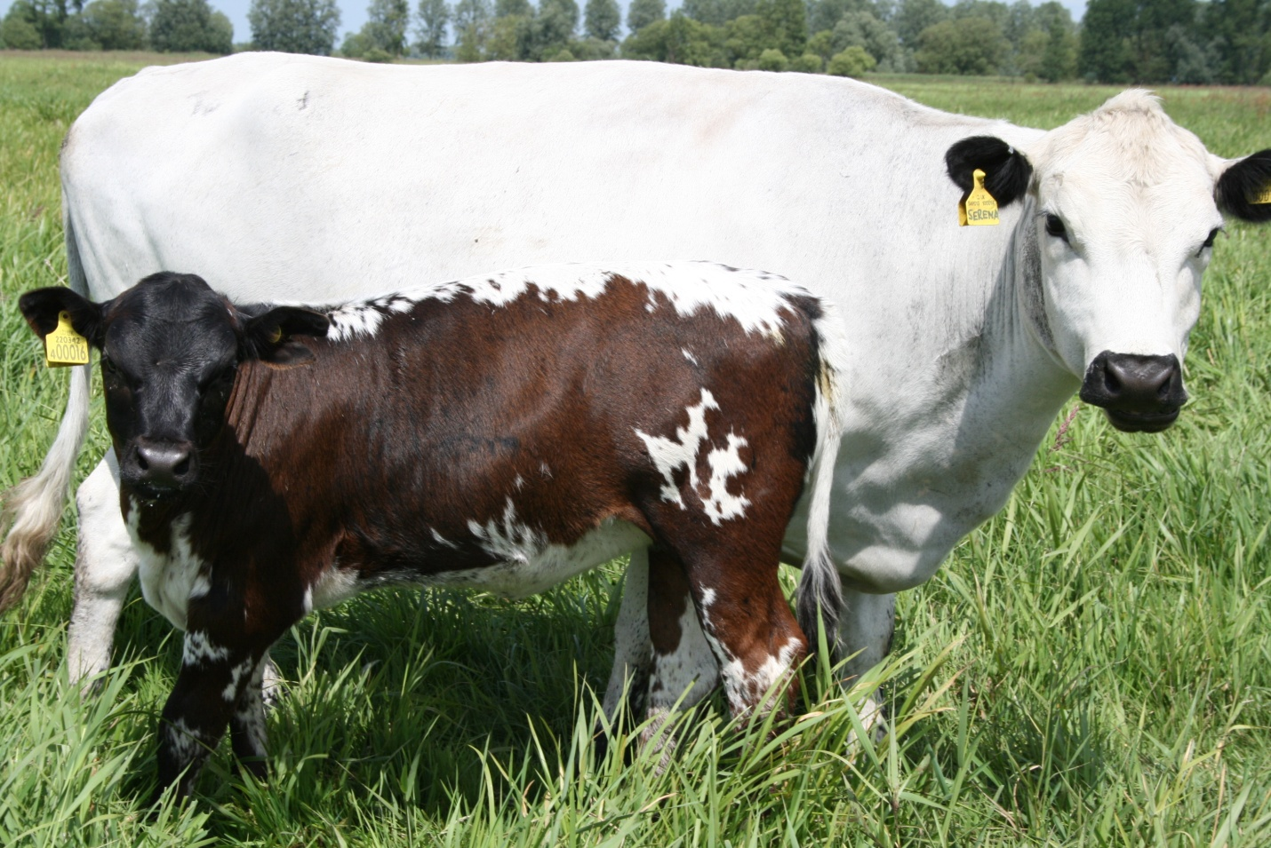

This is poor Peg!

Peg broke her leg as a calf and our vet had to cast and strap the leg. We are happy to report that Peg made a full recovery and will hopefully become one of our breeding cows.
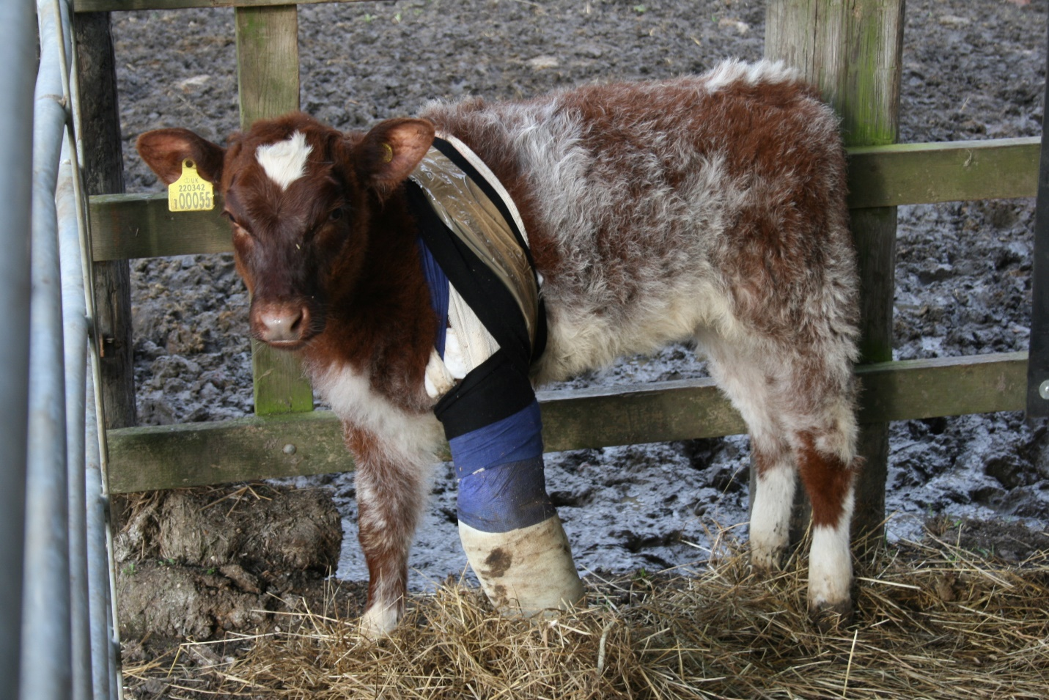

One of the four fishing lakes at Rookery Farm

